VISUAL IMPACT ASSESSMENT FOR A 400KV DOUBLE CIRCUIT TRANSMISSION POWER LINE FROM FIRGROVE TO MITCHELL’S PLAIN AND MITCHELL’S PLAIN SUBSTATION

June 2011

PREPARED BY: |  | PREPARED FOR:
BKS (Pty) Ltd  Environmental Management Department  PO Box 3173  Pretoria  0001 |  | Eskom Holdings Limited  Transmission Division: Land & Rights  PO Box 1091  Johannesburg  2000
CONTACT PERSON |  | CONTACT PERSON
Mr M Howard |  | Mr. K Makhanya
Tel No: 012 421 3500 |  | Tel No: 011 800 2706  Fax No: 011 800 3917
Fax No: 012 421 3601

TITLE | : | VISUAL IMPACT ASSESSMENT
Project Team | : | BKS (Pty) Ltd
Client | : | Eskom Transmission: Land and Rights
BKS Project No | : | J01289
Status of Report | : | Final Revision 01
BKS Report No | : | J01289/V1
Key Words | : | Visual Impact Assessment
Date of this Issue | : | 15 June 2011

For BKS (Pty) Ltd
Compiled by | : | M Howard
 |  | Initials & Surname |  | Signature |  | Date
Reviewed and Approved by | : | B Gordhan
 |  | Initials & Surname |  | Signature |  | Date

EXECUTIVE SUMMARY
Start typing here.
The purpose of the executive summary is to highlight the main findings and recommendations as briefly as possible.
The executive summary includes subject, argument, conclusions and recommendations and should preferably not exceed 1 or 2 pages.
TABLE OF CONTENTS Page No
1. INTRODUCTION 1
2. APPROACH 2
3. ASSUMPTIONS AND LIMITATIONS 2
4. BASELINE CONDITIONS 3
4.1 Description of Works 3
4.1.1 Proposed Mitchell’s Plain Substation 3
4.1.2 Existing Firgrove Substation Upgrade 4
4.1.3 Existing Stikland Substation Upgrade 4
4.1.4 Switching Station 4
4.1.5 Transmission Power Lines 4
4.1.6 Pylon Towers 5
4.2 Natural Physical Elements 7
4.2.1 Landform 7
4.2.2 Land Use 7
4.2.3 Vegetation 8
4.2.4 Wetlands 9
4.2.5 Critical Views and Visibility 9
4.2.6 Genius Loci 10
4.2.7 Visual Quality and Character 10
5. IDENTIFICATION OF RISK SOURCES 12
6. Impact Description and Assessment 13
6.1 The Visual Analysis 13
6.1.1 The Viewshed 13
6.1.2 The Viewing Distance 15
6.1.3 Critical Views 16
6.1.4 The Visual Absorption Capacity 16
6.2 The Visual Impact Assessment 17
6.2.1 Extent and location 17
6.2.2 Duration 17
6.2.3 Intensity 17
6.2.4 Probability 17
6.2.5 Confidence 17
6.2.6 Significance 17
6.2.7 Mitigation 18
7. CONCLUSIONS 18

LIST OF TABLES
Table 4-1: Landscape Assessment Criteria 11

LIST OF FIGURES
Figure 4-1: Self-supporting Tower 5
Figure 4-2: Cross Rope Supporting Tower 5
Figure 4-3: Steel Mono Pole 6
Figure 4-4: Guyed Vee 6
Figure 4-5: Single Mast 6
Figure 4-6: Typical topography of the Cape Flats area 7
Figure 6-1: Viewshed analysis for Athlone 14
Figure 6-2: Viewshed analysis for Glenhaven 14
Figure 6-3: Viewshed analysis for Jacaranda 15
Figure 6-4: Viewshed analysis for Kyalethsa 15

ADDENDA
Addendum A Impact Tables

INTRODUCTION
BKS (Pty) Ltd as the lead consultants for the Environmental Impact Assessment have undertaken the visual assessment investigation for the proposed 400kV double circuit Transmission power line from Firgrove to Mitchell’s Plain and the proposed Mitchell’s Plain Substation in the Western Cape. This visual assessment is a specialist study to determine the visual effects of the proposed Mitchell’s Plain - Firgrove Transmission Line Project on the surrounding environment.

The study area is within an area known as the Cape Flats, within the greater City of Cape Town (CoCT). The focal point to the south of the study area is the N2, which bisects the study area in an east-west direction. Marginalised communities (amongst others, Delft, Khayelitsha, Macassar and Mitchell’s Plain), higher income housing developments and vineyards to the east typify the land uses across the study area. The Khayelitsha wetland system and the Driftsands Nature Reserve are located south and north of the N2 respectively. The northern section of the study area consists of residential areas, industrial areas and corridors where the Kuils River passes through (BKS Final Scoping Report, 2010).

The purpose of this Specialist Study is to determine the impact of the proposed project on the visual and aesthetic character of the proposed alternative routes. The rationale for this Study is that the placement of transmission line may fundamentally alter the landscape character and sense of place of the local environment. The primary objective of this Specialist Study is therefore to describe the potential impact of these structures on the visual character and sense of place of the area. This Specialist Study will have the following objectives:
- Determine the visual character of the areas along the proposed transmission line routes by evaluating environmental components such as topography, current land use activities, surrounding land use activities, etc.;
- Identify elements of particular visual quality that could be affected by the proposed developments;
- Describe and evaluate the specific visual impacts of the preferred 400 kV transmission line and associated infrastructure.
- Recommend mitigation measures to reduce the potential visual impacts generated by the proposed power line.

APPROACH
In order to address the objectives of the study the following method has been used:
- Determine the setting, visual character and land use of the area surrounding the route, and the Genius Loci (sense of place);
- Discussions and meetings with the lead consultant team to identify specific aspects of the construction and development which would affect the visual quality of a setting;
- Define the extent of the affected visual environmental, the viewing distance and the critical views.

The visual impact assessment statements in this report are based on the opinion of the authors and attitudes that are generally accepted worldwide.

ASSUMPTIONS AND LIMITATIONS
The following assumptions and limitations are applicable to this study:
- The assessment does not consider the ancillary project infrastructure and components such as borrow pits, spoil dumps, etc. These components will be assessed in detail during the design phase should the project be implemented;
- The assessment is based on assumed demographic data. No detailed study was done to determine accurate data on potential viewers of the project components. If necessary these studies could be undertaken during the design phase of the project;
- The location and extent of the construction and labour campsites, as well as material lay-down areas will only be determined during the design and construction phases. These are, however, of a relatively temporary nature and can effectively be controlled through the Environmental Management Programme;
- Determining a visual resource in absolute terms is not achievable. Evaluating a landscape’s visual quality is both complex and problematic. Various approaches have been developed but they all have one problem in common; unlike noise or air pollution, which can be measured in a relatively simple way, for the visual landscape mainly qualitative standards apply. Therefore subjectivity cannot be excluded in the assessment procedure (Lange 1994). Individually there is a great variation in the evaluation of the visual landscape based on different experiences, social level and cultural background. Exacerbating the situation is the inherent variability in natural features. Climate, season, atmospheric conditions, region, sub-region all affect the attributes that comprise the landscape. What is considered scenic to one person may not be to another (NLA, 1997);
- The impact assessment is undertaken for the joint team preferred alternative routes only and is not necessarily the preferred route from a visual impact perspective only;
- Localised visual perceptions of the economically depressed communities of the population have not been tested as these may be influenced rather by the economic and job opportunities that will exist rather than the direct visual perception of the project;
- If the study, however, determined that the negative visual impact is of such a magnitude and significance that it will seriously influence the decision on whether or not to build, it will then be necessary to test and determine the visual perceptions of neighbouring communities. Such a study is involved, costly and time consuming.

BASELINE CONDITIONS

Description of Works

Proposed Mitchell’s Plain Substation
The Mitchell’s Plain Substation will be approximately 350m × 350m (or 12.25 ha) in size. However, a 1km corridor will be assessed for alternative 2 and alternative 3 of the proposed Mitchell’s Plain Substation. The Mitchell’s Plain Substation will contain the following infrastructure:
- 2×500MVA MTS.
- 2×400kV Line bays.
- Step down from 400kV to 132kV MTS in order supply the CoCT and Eskom Distribution.
- Telecommunication high mast.
- Administration building and security guard house structure.
- Approximately 3.5m high fencing around the substation site.

Existing Firgrove Substation Upgrade
The Firgrove Substation will be upgraded. However, this proposed development does not form part of this EIA process. The EIA process for this upgrade is being undertaken by another EAP (Enkanyini Projects).

Existing Stikland Substation Upgrade
The proposed upgrade to the existing Stikland Substation entails the addition of a line bay within the boundaries of the site to accommodate the proposed Transmission power line from the Mitchell’s Plain Substation. Therefore, the footprint of the site will not be extended.

Switching Station
A switching station is proposed to be established along the existing 400kV single-circuit Transmission power line from Stikland to Palmiet. This high voltage yard for the switching station would be 300m × 300m in size, which will accommodate any planned future expansion. However, the proposed switching station is to be located south and adjacent to the Stellenbosch Arterial Road at the point where the 400kV Palmiet-Stikland Transmission power line crosses the former road.

No additional alternative locations will be investigated as this location is a suitable distance from the 400kV Transmission power line and does not allow any further deviation from the proposed route alignment of Alternative D from Stikland to the proposed Mitchell’s Plain Substation.

Transmission Power Lines
This project intends establishing a 400kV double-circuit Transmission power line from the proposed Mitchell’s Plain Substation to the existing Firgrove or Stikland Substations, or a proposed Switching Station.

Any change in a local view through the introduction of new power line infrastructure in a viewer’s line of sight can be considered a visual impact.

Overhead Transmission power lines are visually intrusive, and cannot be made otherwise. However, the power line envisaged for this proposed development would limit the visual intrusive nature of power lines within the area. Therefore, the visual impact created by the power lines connected to the substation would only be significant in terms of the cumulative effect of positioning power lines adjacent to one another.

Pylon Towers
Different types of pylon towers can be considered for the proposed development. Different pylon tower types have different impacts on the land use. The alternative pylon structures that were considered are:
- Self-supporting Tower (Figure 4-1);
- Cross Rope Supporting Tower (Figure 4-2);
- Steel Mono Pole (Figure 4-3);
- Guyed Vee (Figure 4-4); and
- Single Mast (Figure 4-5).

Figure 4-1: Self-supporting Tower
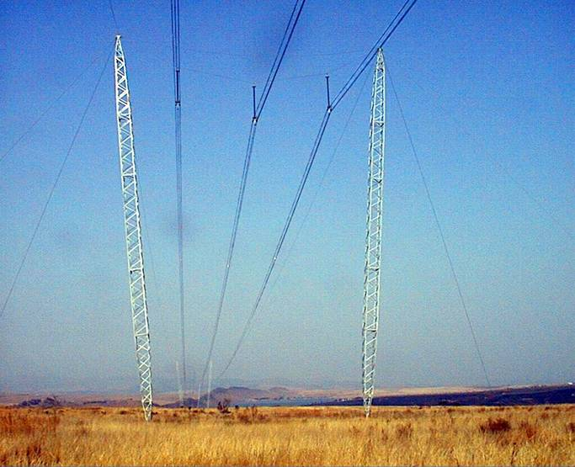
Figure 4-2: Cross Rope Supporting Tower

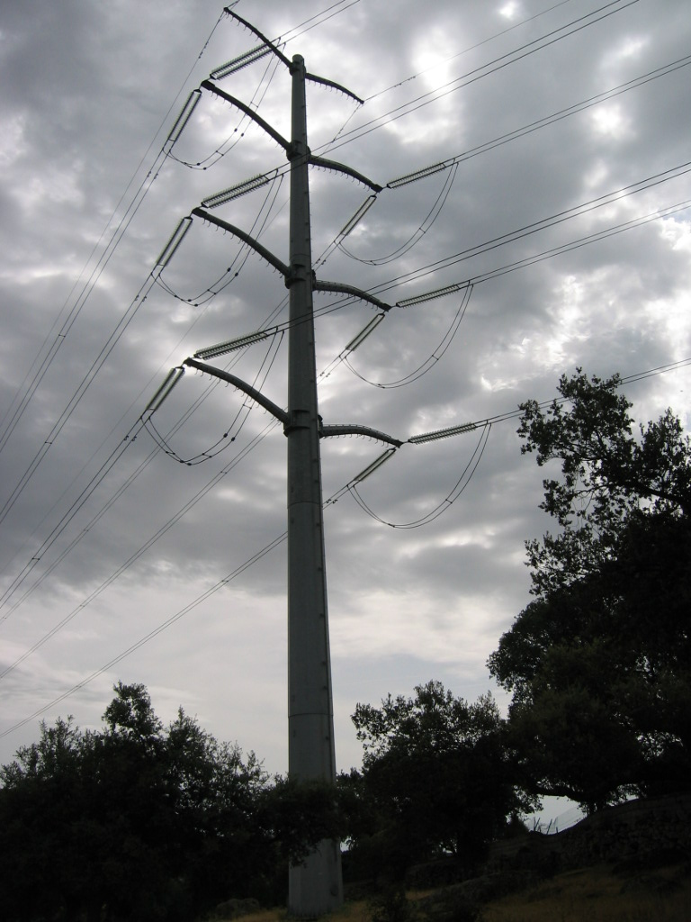
Figure 4-3: Steel Mono Pole
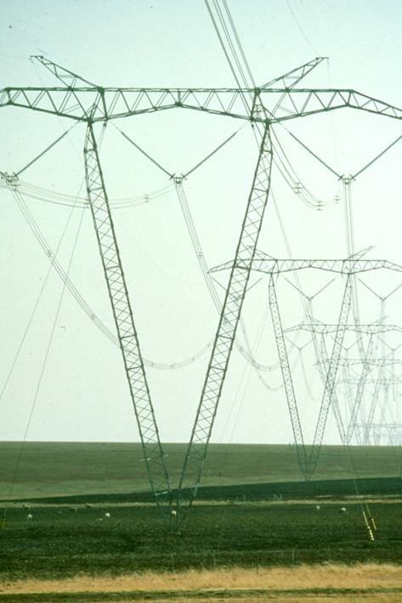
Figure 4-4: Guyed Vee
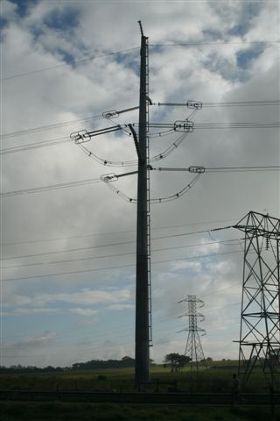
Figure 4-5: Single Mast

Natural Physical Elements

Landform
The Cape Flats regressive inland dune system is situated in the suburbs of Philippi, Mitchell’s Plain and Khayelitsha, which is less than 40m above mean sea level. These stabilised parabolic dunes provide a relatively flat, sandy landscape the majority of which is very low lying, supporting widespread vleis and wetlands (CoCT, 2009a and CoCT, 2009b).

Urban sprawl and agricultural activities have transformed the landscape, resulting in isolated dune remnants of up to 10m (see Figure 4-6).

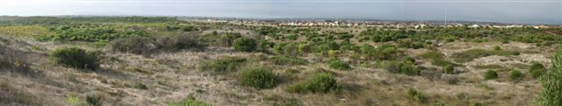
Figure 4-6: Typical topography of the Cape Flats area

Land Use
The study area contains a mix of land uses dedicated to conservation, agriculture, industry and human settlement. The area has a well defined road network, where Vanguard Drive (M7) and the R300 highway provide corridors along which the Transmission power lines have been proposed. These Class 1 roads provide direct access to large portions of the proposed Transmission power lines.

Agricultural activities are limited to small-scale labour-intensive farming of fresh produce crops. Agricultural lands within the study area have been left fallow, awaiting development approvals for estate developments, with exceptions including the Vergenoegd Wine Estate. Small-scale subsistence agriculture has been noted adjacent to the N2 within the Driftsands Nature Reserve. In addition, livestock farming occurs with cattle being seen grazing within the Nature Reserve.

The Khayelitsha and Mitchell’s Plain areas in Cape Town are characterised by dense settlements that lack sufficient services and infrastructure. The CoCT will embark on the upgrading and renewal of these areas which will entail a major investment in affordable housing, poverty alleviation, training and education as well as investment in public and economic infrastructure (2007b).

In terms of residential development, the area has a range of established, largely formal residential neighbourhoods, including much of Mitchell’s Plain (although there are significant numbers of backyard dwellers), and parts of Khayelitsha. The types of dwellings vary from detached single residential units, semi detached units and flats in areas of Mitchell’s Plain and, in a more limited form in Khayelitsha and Philippi. There is also a large informal settlement area, varying in terms of levels of access to services (CoCT, 2009c).

The Driftsands Nature Reserve to the north of Khayelitsha and west of Mfuleni is a provincial nature reserve managed by Cape Nature Conservation. Various high-density informal settlements are situated on the boundaries of this reserve, which increases the socio-economic pressure on the future potential of this area.

Vegetation

Cape Flats Dune Strandveld
The Cape Flats Dune Strandveld is characterised by a flat to undulating landscape covered by tall, evergreen hard-leaved shrubs. Grasses and herbs are also abundant. The veld type is underlain by calcareous sand of marine origin. The conservation status of the Cape Flats Dune Strandveld is Endangered (Mucina & Rutherford, 2006).

Cape Flats Sand Fynbos
The Cape Flats Sand Fynbos has moderately undulating and flat plains with dense and rather tall ericoid shrub lands. This veld type is critically endangered with several endemic taxa (Mucina & Rutherford, 2006).

Swartland Shale Renosterveld
The Swartland Shale Renosterveld has moderately undulating plains and valleys supporting low to moderately tall leptophyllous scrubland. Many endemic plant species occur in this veld type and the veld type is critically endangered (Mucina & Rutherford, 2006).

Swartland Granite Renosterveld
The Swartland Granite Renosterveld occurs on foot slopes and undulating plains. It supports a mosaic of grassland/herb lands and microphyllous shrub land. It is dominated by renosterbos. This vegetation type is classified as critically endangered, as 80% has already been transformed. Approximately 2.5% is statutorily conserved (Mucina & Rutherford, 2006).

Cape Lowland Freshwater Wetlands
The Cape Lowland Freshwater Wetlands occurs in flats and depressions and is normally covered with Phragmites australis and Typha capensis. These wetlands are not unique like the rest of the Fynbos biome, and the vegetation in these wetlands generally occurs worldwide in similar habitats. The soils are fine, silty and clayey soils over young Quaternary sediments. Only 14% of the targeted 24% of this wetland type is statutorily conserved in the Cape Peninsula.

Wetlands
Within the study area, the Kuils River and the Eerste Rivier located, drain southwards to the sea and are associated with wetlands. The wetland systems herein have been named for referencing purposes in this report:
- Firgrove Wetland;
- Airstip Wetland;
- Buffelsvlei Wetland;
- Khayelitsha Wetland;
- Stikland Wetland; and
- Kuils River Wetland.

Critical Views and Visibility
The following areas have been identified as having potential visual impacts:
- Middle ground views of the vineyards from the Vergenoegd Wine Estate and the Zevenwacht Wine Estate, amongst others.
- Distant vistas of the Helderberg and Hottentots Holland mountains.
- MCA Urban & Environmental Planners (2002) state that distant vistas of the Helderberg and Hottentots Holland mountains, as well as the middle ground views of the vineyards have a high visual quality.

Genius Loci
The spirit, or sense, of place is that quality imparted by the aspects of scale, colour, texture, landform, enclosure, and in particular, the land use. According to K. Lynch (1992) “it is the extent to which a person can recognise or recall a place as being distinct from other places as having a vivid, or unique, or at least a particular, character of its own.”

The quality of Genius Loci is a function of attributes such as the scenic beauty or uniqueness and distinctive character of the built and cultural landscape.

The spirit of place varies along the route. The central area of the northern section imparts a rural quality that incorporated aspects of wilderness. The area has a high visual interest due to the mountainous landscape and extended focused views down valleys in relatively unspoilt scenery.

The sense of place to the north can be described as rural agriculture but without a definite scenic ambience. The sense of place in the south is well defined by the mix of diversity of topography and treed savannah, especially in the area around the White Mfolozi River.

Visual Quality and Character
The Landscape Institute/IEMA guidelines for the UK define the following definitions for landscape and visual impacts:

‘…landscape impacts and visual impacts are separate, but related. Landscape impacts are changes in the fabric, character and quality of the landscape. Visual impacts relate solely to changes in available views of the landscape, and the effects of those changes on people.’

The current landscape of this part of the Western Cape is relatively flat, surrounded by the Hottentots Holland Mountains. Table 4-1 presents criteria for landscape assessment (after Landscape Institute/IEMA Guidelines).

Table 4-1: Landscape Assessment Criteria
Highest Quality Landscape | Includes the most aesthetically attractive landscape,. Areas of particular Natural Beauty perceived as special in a regional or national context. Nationally designated land such as National Parks, etc.
Very Attractive Landscape | Areas include historic and designated landscape. Diverse, semi-natural or farmed landscape with natural features. Normally abundant woodlands cover together with a high distribution of trees, hedgerows and shrubs, streams, brooks and other naturalized unpolluted water corridors may be present. Several local landscape designations may apply, including Conservation Areas, and some historical or cultural sites may be present.
Good Quality Landscape | Countryside with some variety in farmland cover. Settlement and villages with pockets of open space and public recreation areas. There is a reasonable distribution of semi-natural vegetation, trees and shrubs cover and the overall view of the area is pleasant. Local landscape designations of cultural and historic value may be present.
Ordinary Quality Landscape | Typical open agricultural land where attractive features are offset by detractors. Some strategic planning is evident but development is primarily functional including housing estates, business parks or urban fringe land uses. Not particular aesthetically attractive, but with more value than a poor quality landscape. Land may be within a Green Belt or have a local landscape designation.
Poor Quality Landscape | Includes detractors such as power lines, industrial derelict or inappropriate built forms with no aesthetic value or evidence of strategic planning. There is lack of mature vegetation cover and no landscape designations apply. Intensively farmed landscape, which has lost most of its features.

The landscape of the Western Cape through which the power line will be installed is predominantly a poor visual quality landscape with small isolated areas of ordinary quality landscape.

IDENTIFICATION OF RISK SOURCES
Various risk sources for the visual impact have been identified for the construction and operation phases and can be classified as both negative and positive.

Construction Phase
It is anticipated that the major risk source during construction would be:
- Negative Risk Sources
  - Excessive cleaning and stripping of topsoil for site offices, servitudes and temporary access road;
  - The relatively random and disorganised lay down of building materials, vehicles and offices;
  - Cut and fill slopes of access roads become highly visible if not re-vegetated and shaped to blend in with the existing topography;
  - The extent and intensity of the security and construction lighting at night;
  - Dust from construction activities;
  - Open and un-rehabilitated landscape scarring;
  - Uncontrolled exploitation of borrow pits and quarries without compliance to environmental controls related to aesthetic rehabilitation;
  - High seed bank of alien species such as Black Wattle (Acacia mearnsii) in the topsoil can lead to the uncontrolled spread of this exotic invader plant species along the edges of the transmission line servitude. This could create a treed edge that is visually contrary to the low grasslands; and
  - Location and layout of construction workers camp if located in proximity of works area.
- Positive Risk Sources
  - Image of construction activity could lead to a perceived view of progress and benefit to the community.
Operational Phase
It is anticipated that the major risk source during operation would be:

- Negative Risk Sources
  - Site engineering such as cuts and fills, could remain aesthetically incompatible with surrounding landscape. Edges may not blend in with the landscape or cut slopes may be too steep to be adequately re-vegetated;
  - Areas and / or specific sites of high aesthetic value may be disfigured by the introduction of project components such as pylons and power lines within the viewshed resulting in a permanent change to the existing visual quality of visually sensitive areas; and
  - Need to keep servitudes clear of vegetation, especially in commercial plantation areas, will result in visual scarring.

Impact Description and Assessment

The Visual Analysis
This section describes the aspects which have been considered in order to determine the intensity of the visual impact on the area. The criteria includes the area from which the project can be seen (the viewshed), the viewing distance, the capacity of the landscape to visually absorb structures and forms placed upon it (the visual absorption capacity), and the appearance of the project from important or critical viewpoints.

The focus of this study is specifically on the main project components such as the power lines, pylons and access roads and not on the ancillary infrastructure.

The Viewshed
The viewshed is a topographically defined area which includes all possible observation sites from which the project will be visible. The boundary of the viewshed, which connects high points in the landscape, is the boundary of possible visual impact (Alonso, et al, 1986). Local variations in topography and man-made structures would cause local obstruction of views.

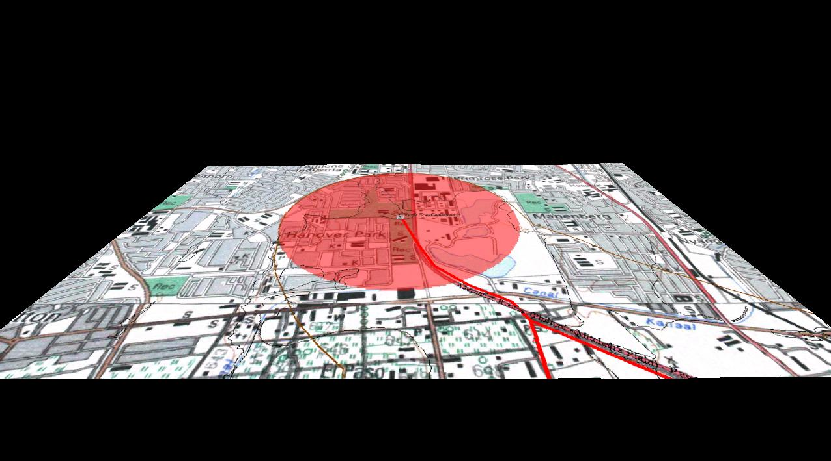
Figure 6-1: Viewshed analysis for Athlone

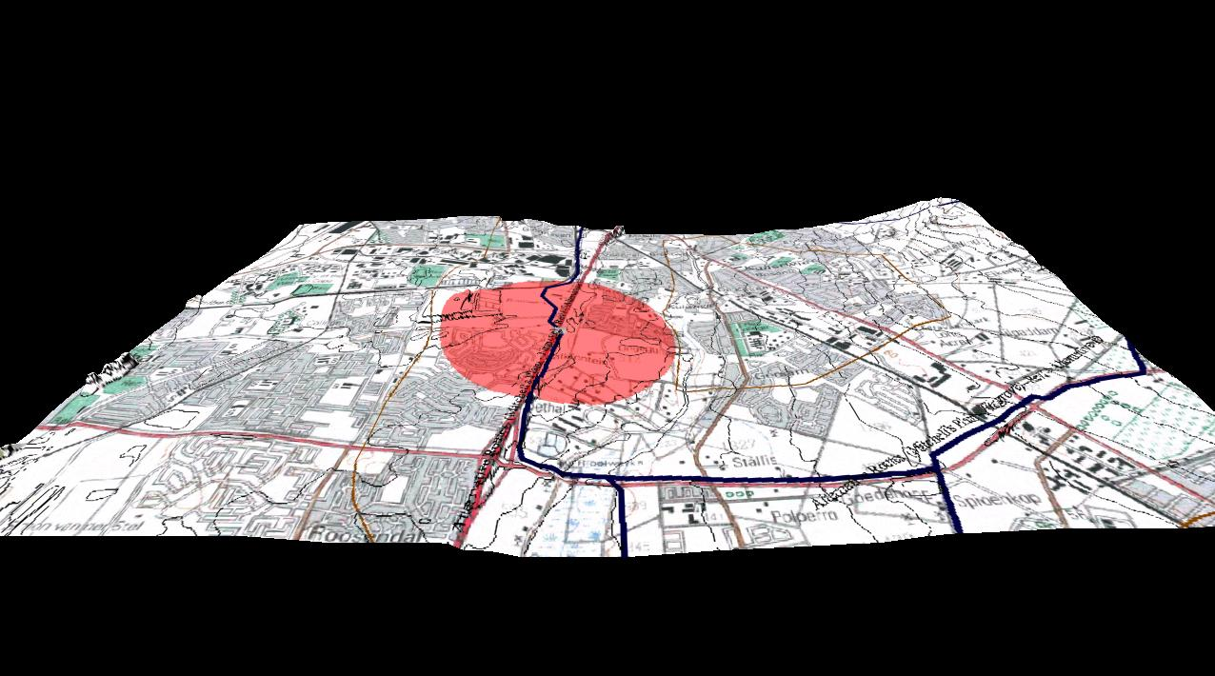
Figure 6-2: Viewshed analysis for Glenhaven

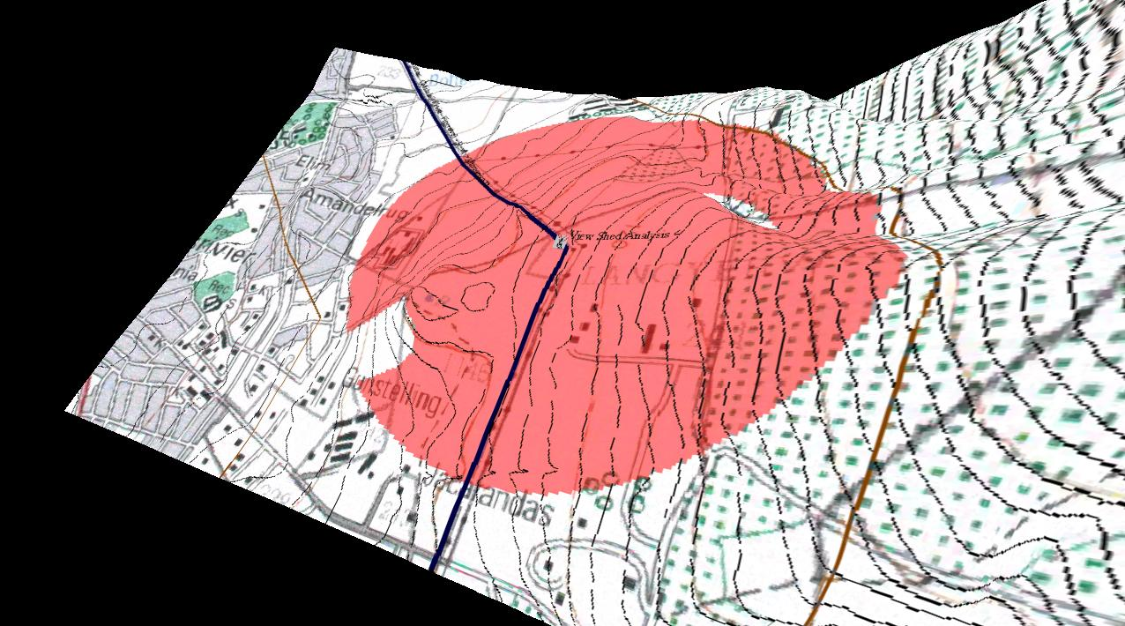
Figure 6-3: Viewshed analysis for Jacaranda

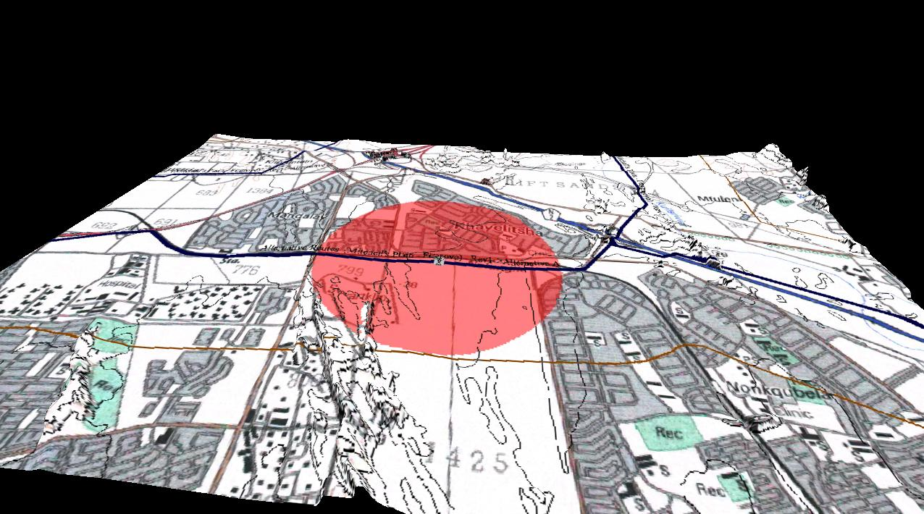
Figure 6-4: Viewshed analysis for Kyalethsa

The viewshed analysis has identified that the proposed lines and pylons will be visible from much of the surrounding land, for a distance up to 1 kilometre.

The Viewing Distance
The visual impact of an object in the landscape diminishes at an exponential rate as the distance between the observer and the object increases (Hull and Bishop, 1988).

Thus, the visual impact at 1000 metres would be approximately a quarter of the impact as viewed from 500 metres. Consequently, at 2000 metres, it would be one sixteenth of the impact at 500 metres. The view of the project components would appear so small from a distance of 5000 metres or more that the visual impact at this distance is insignificant. On the other hand the visual impact of the project components from a distance of 500 metres or less would be at its maximum.

It is important to qualify the above statement by adding that due to the considerable height of the towers (+ 55 m or the equivalent of an 18-storey building), the visibility is often 10 km and beyond. However, due to the nature of the structure at these distances the structures appear ephemeral and tend to blend in with the landscape.

Critical Views
Due to the linear nature of the proposed project it is not possible to provide an adequate descriptive analysis of visibility by plotting sections to determine the line of sight from the observer towards the project components to indicate the extent to which the elements are not screened by the intervening landforms or structures. Areas from where the lines are not visible have been plotted on the viewshed analysis figures above.

The Visual Absorption Capacity
The Visual Absorption Capacity (VAC) is a measure of the landscape’s ability to visually accept /accommodate or embrace a development. Areas which have a high visual absorption capacity are able to easily accept objects so that their visual impact is less noticeable. Conversely areas with low visual absorption capacity will suffer a higher visual impact from structures imposed on them. In this case the VAC has been defined as a function of three factors, based on the author’s field experience.
- Slope
- Visual pattern (landscape texture) with regard to vegetation and structures
- Vegetation height

It is therefore concluded that the VAC of the various routes is high, with only a few areas where the VAC is low. These low VAC areas are confined to the Firgrove to Mitchells Plain eastern section.

The Visual Impact Assessment
The following criteria and assessments were used to evaluate significance of the visual impact of the proposed power lines.

Extent and location
The extent of the potential visual impact was determined in the viewshed analysis. The viewshed analysis has identified that the proposed lines and pylons will be visible from much of the surrounding land, for a distance up to 1 kilometre.

Duration
The impact will be for the duration of the existence of the power lines and pylons.

Intensity
Due to the considerable height of the towers (+ 55 m or the equivalent of an 18-storey building), the visibility is often 10 km and beyond. However, due to the flimsy nature of the structure at these distances the structures appear ephemeral and tend to blend in with the landscape.

Probability
The probability of the impact occurring is definite.

Confidence
The confidence of the impact assessment is high.

Significance
The visual impact of the project and associated structures in the landscape is a function of a number of factors. In light of the process that was adopted for the EIA and the subsequent positioning of the pylons, a select group of criteria was used to define the impacts. These are:

- Category 0 – No impact;
- Category 1 – Slight impact occurs where there is an incremental impact of the additional line to existing electrical installations;
- Category 2 – Some impact occurs as the line is a new piece of infrastructure with an already impacted landscape;
- Category 3 – where a significant impact occurs either as a result of there being no other infrastructure in the vicinity or the pylon will be constructed within an existing township development.
Annexure 1 provides the tables used to rank the visual impact of the proposed power line development.

Mitigation
Mitigation for electrical infrastructure is limited to design options for pylons. As described in the project overview, various pylon types are available, and where possible the least intrusive structure will be used, but in reality these options only mitigate the possible extent of the impact rather than the significance of the visual impact.

CONCLUSIONs
The proposed Firgrove to Mitchells Plain and feed-in to Phillipi will have a visual impact. The significance of the impacts can be summarised as follows.
- Slight impact occurs where there is an incremental impact of the additional line to existing electrical installations;
- Some impacts occur as the line is a new piece of infrastructure with an already impacted landscape;
- Significant impacts occur either as a result of there being no other infrastructure in the vicinity or the pylon will be constructed within an existing township development.

ADDENDUM A:

IMPACT TABLES

Table A1: Impact rating for the Mitchell's Plain - Firgrove Alternative A
SPLIT | PYLON | Mitchell's Plain - Firgrove Alternative A
 |  | VIA Rating | Description of Visual Impact
Aa | 1B | 2 | between urban and R300
Aa | 2B | 2 | between urban and R300
Aa | 3B | 2 | between urban and R300
Aa | 4B | 2 | between urban and R300
Aa | 5B | 1 | alongside railway line (electric)
Aa | 6 | 1 | alongside railway line (electric)
Aa | 7 | 1 | alongside railway line (electric)
Aa | 8 | 1 | alongside railway line (electric)
Aa | 9 | 1 | alongside railway line (electric)
Aa | 10 | 1 | alongside railway line (electric)
Aa | 11 | 1 | alongside railway line (electric)
Aa | 12 | 1 | alongside railway line (electric)
Aa | 13B | 3 | inside township
Aa | 14B | 3 | inside township
Aa | 15B | 2 | industrial
Aa | 16B | 2 | industrial
Ab | 17B | 2 | industrial
Ab | 18B | 1 | existing line
Ab | 19B | 1 | existing line
Ab | 20 | 1 | existing line
Ab | 21 | 1 | existing line
Ab | 22 | 1 | existing line
Ab | 23 | 1 | existing line
Ab | 24 | 1 | existing line
Ab | 25 | 1 | existing line
Ab | 26a | 1 | existing line
Ab | 26b | 1 | existing line
Ab | 27B | 1 | existing line
Ab | 28 | 1 | existing line
Ab | 29 | 1 | existing line
Ab | 30 | 1 | existing line
Ab | 31 | 1 | existing line
Ab | 32 | 2 | open area, viewshed from N2
Ab | 33 | 2 | open area, viewshed from N2
Ab | 34 | 2 | open area, viewshed from N2
Ab | 35 | 2 | open area, viewshed from N2
Ab | 36B | 2 | open area, viewshed from N2
Ab | 37B | 2 | open area, viewshed from N2
Ab | 38B | 2 | open area, viewshed from N2
Ab | 39 | 2 | open area, viewshed from N2
Ab | 40 | 1 | existing line
Ab | 41 | 1 | existing line
Ab | 42 | 1 | existing line
Ab | 43 | 1 | existing line
Ab | 44 | 1 | existing line
Ab | 45B | 1 | existing line
Ab | 46B | 1 | existing line
Ab | 47 | 2 | between township and N2
Ab | 48B | 2 | between township and N2
Ab | 49B | 2 | open areas other side of N2 from Township
Ab | 50 | 2 | open areas other side of N2 from Township
Ab | 51 | 2 | open areas other side of N2 from Township
Ab | 52 | 2 | open areas other side of N2 from Township
Ab | 53B | 2 | open areas other side of N2 from Township
Ab | 54B | 2 | open areas other side of N2 from Township
Ab | 55Ba | 1 | Other electricity infrastructure
Ab | 55Bb | 1 | Other electricity infrastructure
Ab | 56B | 1 | Other electricity infrastructure
Ab | 57 | 1 | Other electricity infrastructure
Ab | 58a | 0 | No impact
Ab | 58b | 0 | No impact

Table A2: Impact rating for the Mitchell's Plain Substation
PYLON | Mitchell's Plain Substation
 | VIA | Description of Visual Impact
1 | 1 | Other electricity infrastructure
2 | 2 | Other Infrastructure
3 | 3 | Open Area

Table A3: Impact rating for the Mitchell's Plain - Stikland C
SPLIT | PYLON | Mitchell's Plain - Stikland C
 |  | VIA Rating | Description of Visual Impact
Ca | 1 | 1 | Other Electricity infrastructure
Ca | 2B | 2 | alongside Sheffield road and informal and township area
Ca | 3B | 2 | alongside Sheffield road and informal and township area
Ca | 4B | 2 | alongside Sheffield road and informal and township area
Ca | 5 | 2 | alongside Sheffield road and informal and township area
Ca | 6B | 2 | alongside Sheffield road and informal and township area
Ca | 7B | 2 | alongside Sheffield road and informal and township area
Ca | 8B | 2 | alongside Sheffield road and informal and township area
Ca | 9B | 2 | alongside Sheffield road and informal and township area
Ca | 10 | 2 | alongside Sheffield road and informal and township area
Ca | 11 | 2 | alongside Sheffield road and informal and township area
Ca | 12B | 2 | alongside Sheffield road and informal and township area
Ca | 13B | 2 | alongside Sheffield road and informal and township area
Ca | 14 | 2 | alongside Sheffield road and informal and township area
Ca | 15 | 2 | alongside Sheffield road and informal and township area
Ca | 16Ba | 2 | alongside Sheffield road and informal and township area
Ca | 16Bb | 2 | alongside Sheffield road and informal and township area
Ca | 17a | 2 | alongside Sheffield road and informal and township area
Ca | 17b | 2 | alongside Sheffield road and informal and township area
Ca | 18B | 1 | existing line
Ca | 19B | 1 | existing line
Ca | 20 | 1 | existing line
Ca | 21 | 1 | existing line
Ca | 22 | 1 | existing line
Ca | 23 | 1 | existing line
Ca | 24 | 1 | existing line
Ca | 25B | 1 | existing line
Ca | 26 | 1 | existing line
Ca | 27 | 1 | existing line
Ca | 28 | 1 | existing line
Ca | 29a | 1 | existing line
Ca | 29Bb | 1 | existing line
Ca | 30Ba | 1 | existing line
Ca | 30Bb | 1 | existing line
Ca | 31 | 1 | existing line
Ca | 32 | 1 | existing line
Ca | 33 | 1 | existing line
Ca | 34 | 1 | existing line
Ca | 35B | 1 | existing line

Table A4: Impact rating for the Mitchell's Plain - Stikland D
SPLIT | PYLON | Mitchell's Plain - Stikland D
 |  | VIA | Description of Visual Impact
Da | 1Ba | 2 | Proximity to N2 (only viewshed)
Da | 1Bb | 2 | Proximity to N2 (only viewshed)
Da | 2Ba | 2 | Proximity to N2 (only viewshed)
Da | 2Bb | 2 | Proximity to N2 (only viewshed)
Da | 3 | 3 | open land, no infrastructure or buildings
Da | 4 | 3 | open land, no infrastructure or buildings
Da | 5 | 3 | open land, no infrastructure or buildings
Da | 6B | 3 | open land, no infrastructure or buildings
Da | 7 | 3 | open land, no infrastructure or buildings
Da | 8 | 3 | viewshed from township to open land impacted
Da | 9B | 3 | viewshed from township to open land impacted
Da | 10 | 3 | viewshed from township to open land impacted
Da | 11a | 1 | existing lines
Da | 11Bb | 1 | existing lines
Db | 12Ba | 2 | Other infrastructure
Db | 12Bb | 2 | Other infrastructure
Db | 13a | 2 | Other infrastructure
Db | 13b | 2 | Other infrastructure
Db | 14ba | 3 | open area viewshed from township interrupted
Db | 14Bb | 3 | open area viewshed from township interrupted
Db | 15a | 3 | open area viewshed from township interrupted
Db | 15b | 3 | open area viewshed from township interrupted
Db | 16Ba | 3 | open area viewshed from township interrupted
Db | 16Bb | 3 | open area viewshed from township interrupted
Db | 17B | 3 | open area viewshed from township interrupted
Db | 18Ba | 3 | open area viewshed from township interrupted
Db | 18Bb | 3 | open area viewshed from township interrupted
Db | 19Ba | 1 | existing line
Db | 19Bb | 1 | existing line
Db | 20 | 1 | existing line
Db | 21a | 1 | existing line
Db | 21b | 1 | existing line
Db | 22 | 2 | Other infrastructure
Db | 23a | 3 | open area
Db | 23b | 3 | open area
Db | 23Bc | 3 | open area
Db | 24a | 2 | Stellenbosch road and industrial
Db | 24Bb | 2 | Stellenbosch road and industrial
Db | 24Bc | 2 | Stellenbosch road and industrial
Db | 24d | 2 | Stellenbosch road and industrial
Db | 24Be | 2 | Stellenbosch road and industrial
Db | 25Ba | 2 | Stellenbosch road and industrial
Db | 25Bb | 2 | Stellenbosch road and industrial
Db | 25Bc | 2 | Stellenbosch road and industrial
Db | 26Ba | 2 | Stellenbosch road and industrial
Db | 26Bb | 2 | Stellenbosch road and industrial
Db | 27a | 2 | Stellenbosch road and industrial
Db | 27b | 2 | Stellenbosch road and industrial
Db | 27c | 2 | Stellenbosch road and industrial
Db | 28a | 1 | industrial area
Db | 28Bb | 1 | industrial area
Db | 29 | 1 | industrial area
Db | 30B | 1 | industrial area
Db | 31B | 1 | industrial area
Db | 32B | 1 | industrial area
Db | Gantry 1 | 1 | existing line
Db | Gantry 2 | 1 | existing line
Db | Gantry 3 | 1 | existing line
Db | Gantry 1a | 1 | existing line
Db | Gantry 2a | 1 | existing line
Db | Gantry 3a | 1 | existing line
Dc | 33B | 1 | existing line
Dc | 34B | 1 | existing line
Dc | 35 | 1 | existing line
Dc | 36 | 1 | existing line
Dc | 37 | 1 | existing line
Dc | 38 | 1 | existing line
Dc | 39 | 1 | existing line
Dc | 40 | 1 | existing line
Dc | 41B | 1 | existing line
Dc | 43B | 1 | existing line
Dc | 44 | 1 | existing line
Dc | 45B | 1 | existing line
Dc | 46B | 1 | existing line
Dc | 47 | 1 | existing line
Dc | 48 | 1 | existing line
Dc | 49 | 1 | existing line
Dc | 50B | 1 | existing line
Dc | 51 | 1 | existing line

Table A5: Impact rating for the Philippi - Mitchell's Plain Alternative 1
SPLIT | PYLON | Philippi - Mitchell's Plain Alternative 1
 |  | VIA Rating | Description of Visual Impact
1a | 1 | 1 | existing substation
1a | 2 | 1 | industrial
1a | 3 | 1 | industrial
1a | 4B | 2 | vanguard rd, open, industry set well back from road
1a | 5 | 2 | vanguard rd, open, industry set well back from road
1a | 6Ba | 2 | vanguard rd, open, industry set well back from road
1a | 6Bb | 2 | vanguard rd, open, industry set well back from road
1b | 7B | 2 | vanguard rd, open, industry set well back from road
1b | 8 | 2 | vanguard rd, open, industry set well back from road
1b | 9 | 3 | open area, no industry
1b | 10 | 3 | open area, no industry
1b | 11B | 2 | proximity to infrastructure, no pylons
1b | 12Ba | 2 | proximity to infrastructure, no pylons
1b | 12b | 2 | proximity to infrastructure, no pylons
1b | 13Ba | 2 | proximity to infrastructure, no pylons
1b | 13Bb | 2 | proximity to infrastructure, no pylons
1b | 14Ba | 2 | proximity to infrastructure, no pylons
1b | 14Ba | 2 | proximity to infrastructure, no pylons
1b | 15 | 2 | proximity to infrastructure, no pylons
1b | 16 | 2 | proximity to infrastructure, no pylons
1b | 17B | 2 | proximity to infrastructure, no pylons
1b | 18a | 2 | proximity to infrastructure, no pylons
1b | 18Bb | 2 | proximity to infrastructure, no pylons
1b | 18Bc | 2 | proximity to infrastructure, no pylons
1b | 18Bd | 2 | proximity to infrastructure, no pylons
1c | 19 | 3 | inside township
1c | 20 | 3 | inside township
1c | 21 | 3 | inside township
1c | 22 | 3 | inside township
1c | 23 | 2 | between township and R300
1c | 24 | 2 | between township and R300
1d | 25 | 2 | between township and R300
1d | 26Ba | 2 | between township and R300
1d | 26Bb | 2 | between township and R300
1d | 27Ba | 1 | other infrastructure planned
1d | 27Bb | 3 | inside squatter camp
1d | 28 | 1 | other infrastructure planned

Table A6: Impact rating for the Philippi - Mitchell's Plain Alternative 2
PYLON | Philippi - Mitchell's Plain Alternative 2
 | VIA | Description of Visual Impact
1B | 3 | middle of agricultural holdings
2B | 3 | middle of agricultural holdings
3 | 3 | middle of agricultural holdings
4 | 3 | middle of agricultural holdings
5B | 3 | middle of agricultural holdings
6B | 3 | middle of agricultural holdings
7 | 3 | middle of agricultural holdings
8B | 3 | middle of agricultural holdings
9Ba | 3 | middle of agricultural holdings
9Bb | 3 | middle of agricultural holdings
10a | 3 | middle of agricultural holdings
10b | 3 | middle of agricultural holdings
11B | 3 | middle of agricultural holdings
12B | 3 | middle of agricultural holdings
13B | 3 | middle of agricultural holdings

Table A7: Impact rating for the Philippi - Mitchell's Plain Alternative 3
SPLIT | PYLON | Philippi - Mitchell's Plain Alternative 3
 |  | VIA | Description of Visual Impact
3a | 1 | 2 | Adjacent to road, vicinity of urban areas and some industry
3a | 2 | 2 | Adjacent to road, vicinity of urban areas and some industry
3a | 3B | 2 | Adjacent to road, vicinity of urban areas and some industry
3b | 4B | 2 | Adjacent to road, vicinity of urban areas and some industry
3b | 5 | 2 | Adjacent to road, vicinity of urban areas and some industry
3b | 6B | 2 | Adjacent to road, vicinity of urban areas and some industry
3b | 7 | 2 | Adjacent to road, vicinity of urban areas and some industry
3b | 8B | 2 | Adjacent to road, vicinity of urban areas and some industry
3b | 9 | 2 | Adjacent to road, vicinity of urban areas and some industry
3b | 10B | 2 | Adjacent to road, vicinity of urban areas and some industry
3b | 11B | 2 | Adjacent to road, vicinity of urban areas and some industry
3b | 12 | 2 | Adjacent to road, vicinity of urban areas and some industry
3b | 13B | 2 | Adjacent to road, vicinity of urban areas and some industry
3b | 14B | 2 | Adjacent to road, vicinity of urban areas and some industry

Table A8: Impact rating for the Philippi - Mitchell's Plain Alternative 4
PYLON | Philippi - Mitchell's Plain Alternative 4
 | VIA | Description of Visual Impact
1B | 2 | adjacent to industry
2 | 2 | adjacent to industry
3 | 3 | open area
4 | 3 | open area
5 | 3 | open area

